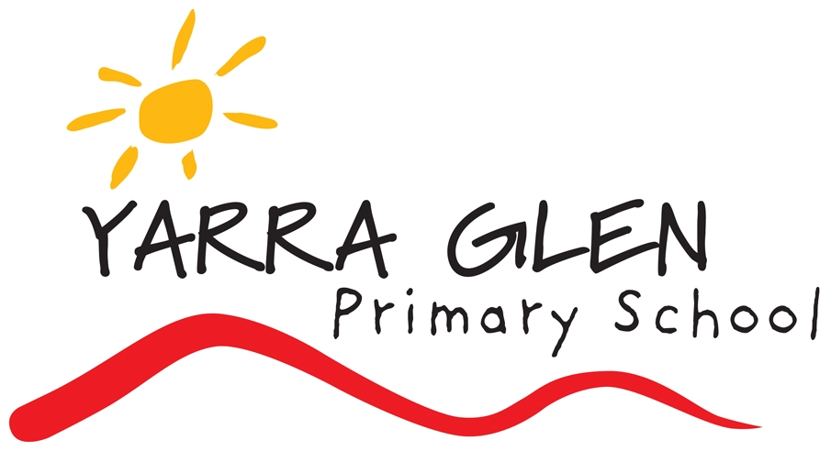 | SCHOOL PHILOSOPHY - VISION
Statement of philosophy, which includes Government School’s vision, mission, values and objectives.
Our school’s vision is to prepare young people to become active, engaged and responsible citizens of the local and global community. It aims to prepare students to contend with a very dynamic 21st century in which creativity, cooperative work, connectedness to the world and adaptability are key features. The school aspires to provide a contemporary approach to teaching and learning in its purposeful learning environment.
The school values high achievement, Persistence, Encouragement, Respect, Resilience and Inclusiveness. Our school believes, all students should be safe in all school environments and have high aspirations.
Instilling pride in our students is vital.
The programs and teaching in the school will support and promote the principles and practices of Australian democracy including a commitment to:
- an elected government
- the rule of law
- equal rights for all before the law
- freedom of religion
- freedom of speech and association
- the values of openness and tolerance
- child safety

Statements which affirm the school’s principles are found in the school vision and in documents such as our Strategic Plan, Annual Implementation Plan and School Policies.

Enactment of school philosophy.
Our core business is teaching and learning. “We teach your child, rather than ‘just the curriculum.” Regular evaluation processes will be in place to measure all areas of the school’s performance with respect to the implementation of the vision and values of the school.

Date of Adoption: 20140723
Date of Review: 20160721
Date of Review: 20170525

