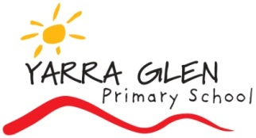

Media Permission Form

July, 2017
Dear Parents,

As student progress in their education, there may be opportunities for them to explore themes, ideas and other educational avenues at a higher level. On some of these occasions, the use of resources such as videos, documentaries, demonstrations, with a PG rating is required. As per the Department of Communications and the Arts - who regulate classifications – PG, or Parental Guidance, is considered mild in impact.

​Parental Guidance (PG)
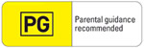
The content is mild in impact.
The impact of PG (Parental Guidance) classified films and computer games should be no higher than mild, but they may contain content that children find confusing or upsetting and may require the guidance of parents and guardians. They may, for example, contain classifiable elements such as language and themes that are mild in impact.
(http://www.classification.gov.au/Guidelines/Pages/PG.aspx)

As teachers, we are permitted to present content with a G (General) classification, however permission is required for any content with a PG rating. Please complete the form below and return to your child’s teacher.

Regards,
Kath, Kelli and Kay

PERMISSION FORM

I do / do not (please circle one) authorise my child to view content rated PG (Parental Guidance) for educational purposes.

NAME:__________________________________________ GRADE: _________________

Parent/guardian: ____________________________________ (full name)

____________________________________ (signature) ____________ (date)

