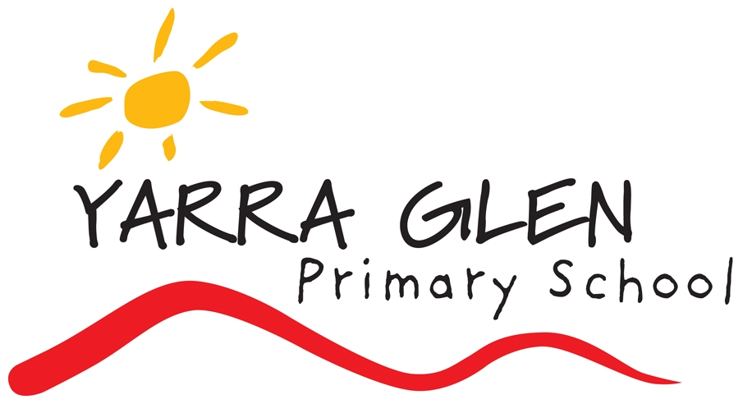 | UNIFORM POLICY

Rationale:
The Yarra Glen Primary School Uniform Policy reinforces in students a pride in their own appearance, instils recognition of themselves as an integral part of the school community, and assists in developing pride in representing their school. Issues of equality, health and safety, and expense are also factors that contribute to the establishment of the dress code.

Aims:
- To promote unity and equality amongst all students
- To further develop a sense of pride in, and identification with our school
- To provide durable clothing that is cost effective and practical for our school environment, enabling students to safely engage in the many varied school activities
- To maintain and enhance the positive image of the school in the community.

Implementation:
- After consultation with the school community and our senior students, School Council has developed a Student Dress Code that we believe provides choice for the students, allows for students to safely engage in the many varied school activities, and caters for the financial constraints of families.
- The details of the Student Dress Code and the uniform shop hours of operation will be made available to parents either on the website or in hardcopy form (e.g. in Information Packs).
- The Student Dress Code applies during school hours, while travelling to and from school, and when students are on school excursions or events.
- Only on gazetted special “Free Dress” days will the Student Dress Code not apply.
- Summer and Winter uniforms, as well as sports uniforms will be prescribed, and are required to be worn.
- Interschool sports uniforms will only be available for students in Grades 3-6.
- Footwear should be sensible and practical for school activities and provide support and stability for the wearer. No steel capped boots, thongs or open toed footwear is to be worn
- Stud earrings and sleepers worn in the ears, plus watches are the only acceptable jewellery. Due to safety reasons, long earrings are not allowed to be worn at school.
- Hair longer than shoulder length needs to be properly tied back at all times.
- Extreme hair colours (e.g.: green, pink or purple rinses) and/or extreme hairstyles (e.g. spikes or mohawks) are not permitted.
- No make up is to be worn at school.
- The only headwear that is acceptable is a Sunsmart hat consistent with our Sunsmart policy or plain coloured beanies during Winter. Hats must be worn outside from Term 1, Term 2 (until 30th April), Term 3 (from 1st September) and Term 4. Hats are not to be worn inside. (An exemption is made for religious scarves; however these should be black, white or red to fit in with the uniform colours).
- Sunglasses are encouraged to be worn in warmer months, but this is a parental decision.
- Good quality second hand uniforms can be purchased from the uniform store at YGPS.
- School Council requires the Principal together with the YGPS teaching faculty to be responsible for the enforcement of the Dress Code in a manner consistent with the Student Code of Conduct.
- If students do not adhere to the YGPS Student Dress Code parents will be contacted to discuss the matter.
- Arrangements can be made to supply uniforms for families experiencing economic hardship.
- Parents seeking exemptions to the Student Dress Code due to religious beliefs, ethnic or cultural background, student disability, health condition or economic hardship must apply in writing to the School Principal.

Evaluation:
- This policy will be reviewed as part of the annual parent opinion survey, specific surveys aimed at determining the level of support for specific uniform items and by School Council as required.
- Consideration will be given to the level of support given to the uniform policy by the number of issues raised compared to the level of compliance relating to wearing the school uniform.
- This policy will be reviewed as part of the school’s three-year review cycle.

School Council policy is that the school uniform is compulsory. All children from Years Foundation - 6 are required to wear only the official school uniform as per the following list. Parents need to be aware that failure by children to wear the school uniform may result in a uniform infringement note being given to the child or parents being contacted.

STUDENT DRESS CODE
Summer Uniform
Short sleeve polo shirt Red with black/red collar and logo
Plain red
Sport shirt Black with red detail and logo
Shorts Black
Summer dress Red and white gingham check
Skirt/skorts Plain black
Bike shorts Black (to be worn under dresses/skirts only)
Socks Plain white or black socks
Footwear Plain black
Hat Wide brimmed red hat with logo (bucket or slouch style).
Caps are NOT acceptable.

Winter Uniform
Bomber jacket Black with red stripes and logo
Polar fleece jumper ½ zip red with black logo
Fleece jumper/hoodie Plain black/red with logo or unbranded
Long sleeve polo shirt Red with black/red collar and logo
Winter skirt/skorts Black
Pants Black (no brand names or jeans)
Socks/Tights Plain black tights/socks or white socks
Footwear Plain black, no steel capped boots
Hat Plain red/black beanie

House Sports Uniform
T-shirt Plain shirt in house colours (red, royal blue, gold, purple)

Specialised uniforms
Grade Six Graduation Tops
- Graduation tops to be decided each year after discussion with Year Five students and staff.
- Decision to be made during Semester 2 by present Year Fives and staff.

School Bag
- A black school bag with logo is available, however is optional as long as an alternative suitable bag is provided.
Uniform can be ordered via the school office or online via the APLUS Schoolwear website. Deliveries will be made to the school or directly to your home for a small additional cost. Part of our Prep transition program will include a visit by APLUS Schoolwear to attend our school . Using this process, children can be measured accordingly for their uniform to enable a suitable order to be made.

Date of Adoption: 2010
Date of Review: 20180806

